Payeer for CMS Joomla 3.4.8 – Virtuemart 3.0.9

In the admin panel, open the extensions Manager.
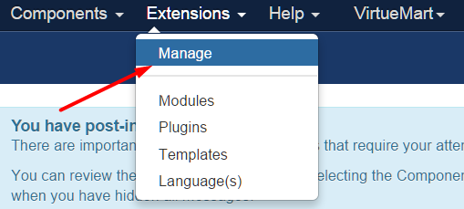

Select the file Payeer (3.4.8 Joomla - Virtuemart 3.0.9) ru, en.zip and click “Upload & Install”.
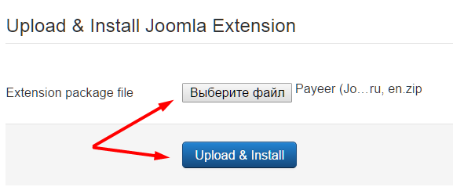

After installation you should receive a notification about successful installation.
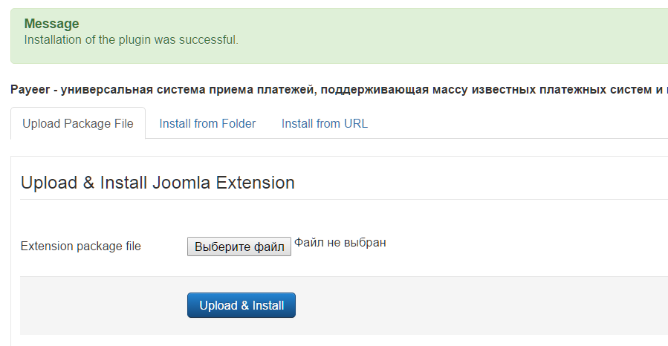

In the VirtueMart menu go to “Payment Methods”.
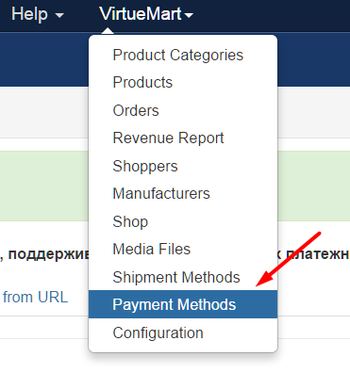

Create a new payment method by clicking the button “New”.
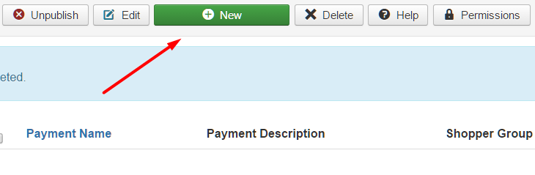

In the tab “Payment Method Information” specify basic information about the method of payment, publish and select from the list “Payment Method” VMPAYMENT_PAYEER. Then click “Save”.
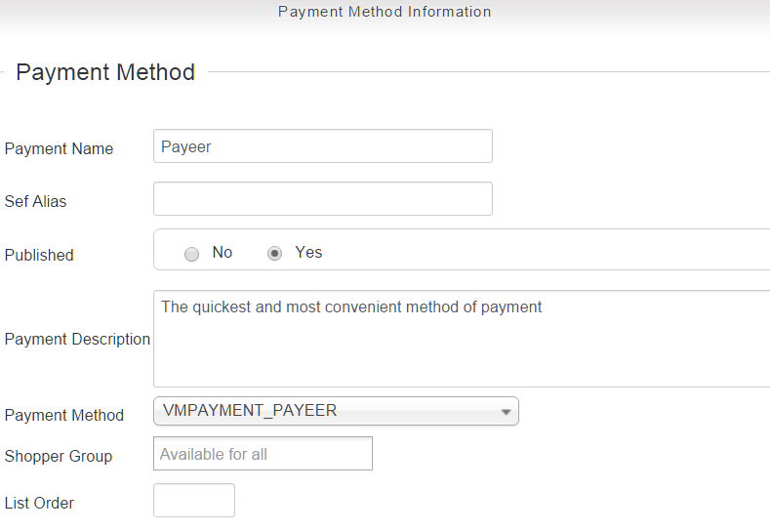

In the tab “Configuration” to specify the settings of the payment system Payeer.
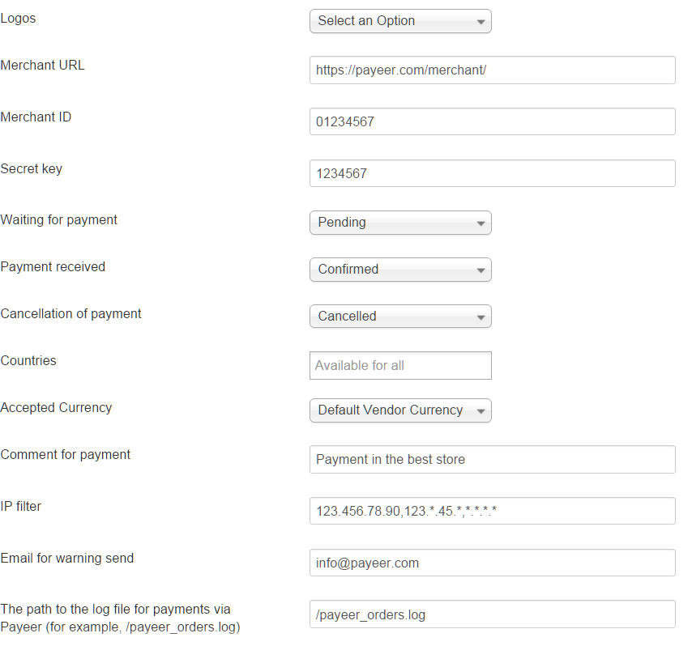

Merchant URL: the default path to the payment https://payeer.com/merchant/
Merchant ID: id of your store in the system Payeer.com (can be found in the personal cabinet).
Secret key: the secret key of your store, also issued to you when registering in the system.
The path to the log file: if you specify the path to the file logging, you will be recording information about payments via Payeer.
IP filter: You can specify the list of all trusted ip addresses of servers, separated by commas. You can also specify a mask instead of the ip address. If the field is empty, checking for trusted ip addresses is not performed.
For example:
192.168.71.87, 192.165.83.17, 192.178.34.15
Or 192.*.71.87, 192.165.83.*, 192.*.34.15
Or *.*.*.* - all available ip addresses

Email for warning send: enter your email address to receive notices in the event of an error of payment. The letter will state the reason and basic information about the payment.
Click "Save".

Then on the website payeer.com in the dashboard, enter the URL address in the store settings.
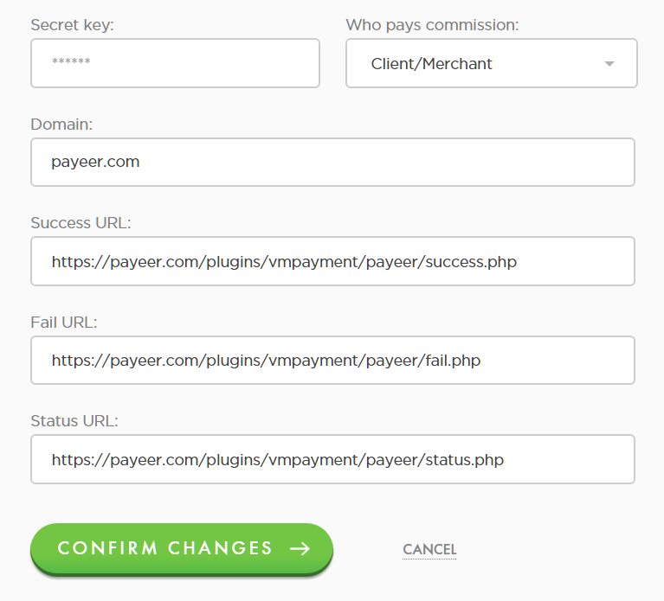

Success URL
http:// *****/plugins/vmpayment/payeer/success.php
Fail URL
http:// *****/plugins/vmpayment/payeer/fail.php
Status URL
http:// *****/plugins/vmpayment/payeer/status.php
Where ***** is your domain.
Confirm changes.
Module Payeer for CMS Joomla 3.4.8 – Virtuemart 3.0.9 configured.

